DSA course with kunal Kushwaha

Types of languages

1. Procedural Programming

* Procedural languages , it specifies a series of well-structured steps and procedures to compose a program
* It contains a specific order of functions statements and commands to complete a task

2) Functional Programming

* Writes a program only in pure functional way and never modifying the existing variables instead providing new ones as an output
* It is generally used in situations when the data is same and different operations are to be performed
* First class functions – read about it

1. Object Oriented Programming

* Revolves around objects
* Code + Data = Object
* Developed to make it easier to develop, debug, reuse and maintain sotware

STATIC VS DYNAMIC

Static

* Perform type checking at compile time
* Error will show at compile time
* Declare datatype before you use it
* More control

Dynamic

* Perform type checking at runtime
* Error will show at runtime
* No need to declare data type before you use it
* Saves time but may give errors in runtime

Memory Management

Visualization

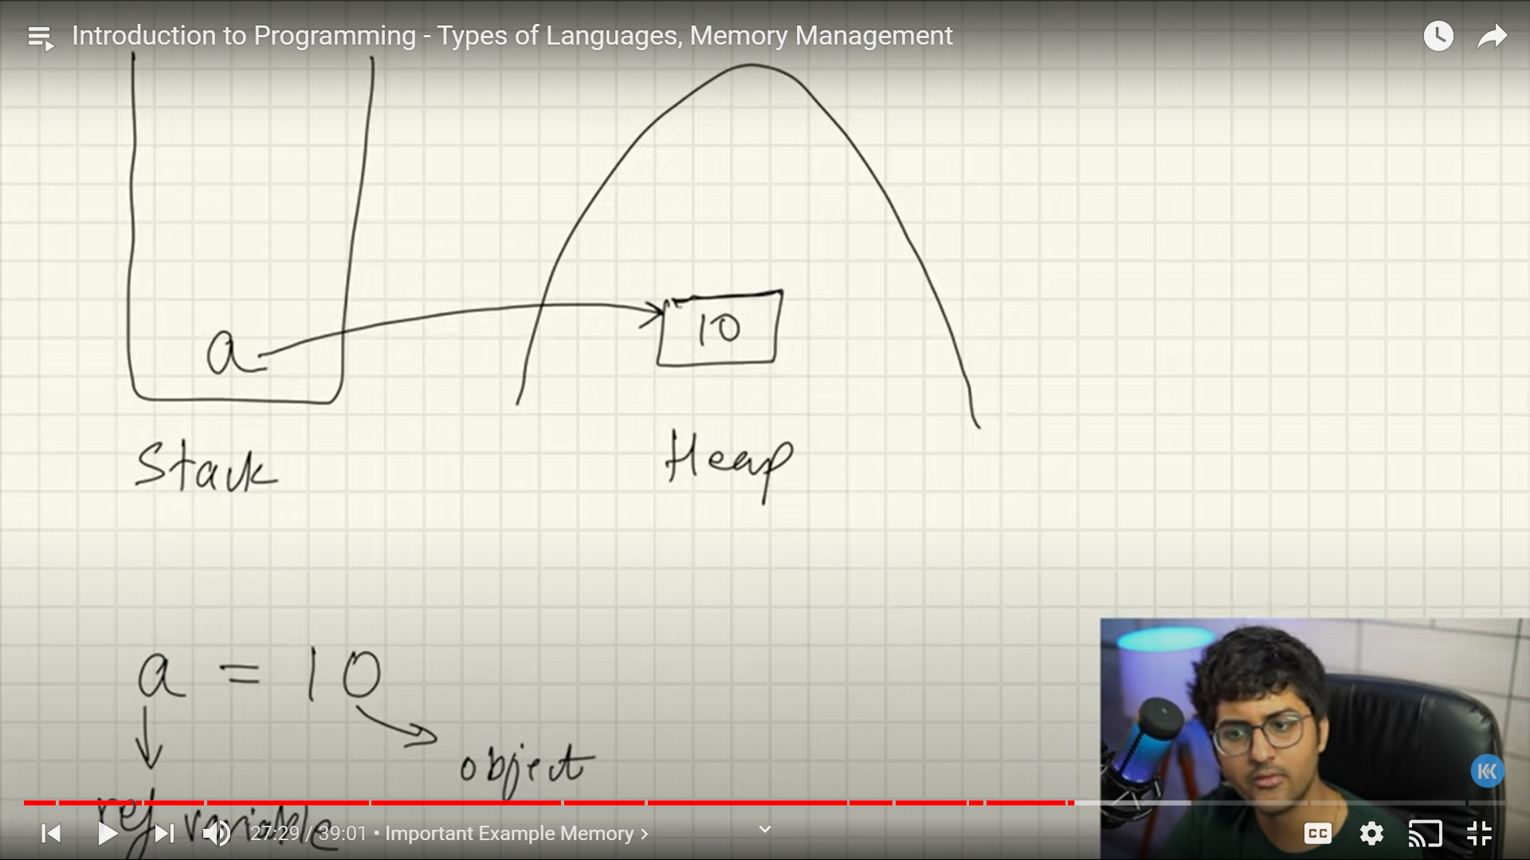

Reference variables

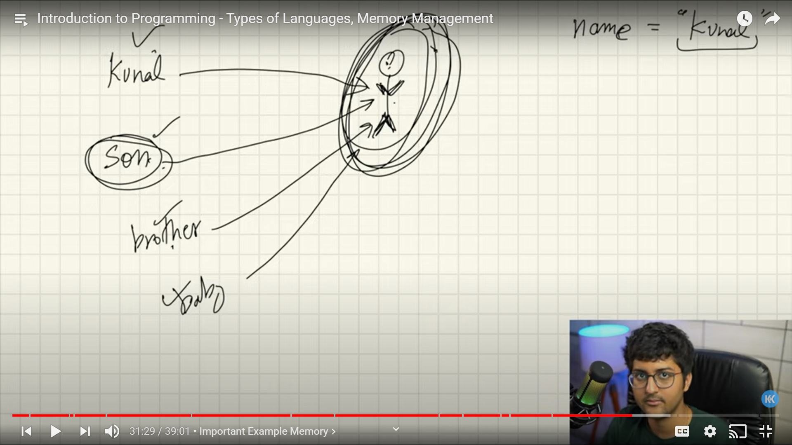

Note – Java doesn’t have pass by reference or pass by value , It only has pass by reference value

Garbage Collection

Removing the object with no reference from the memory

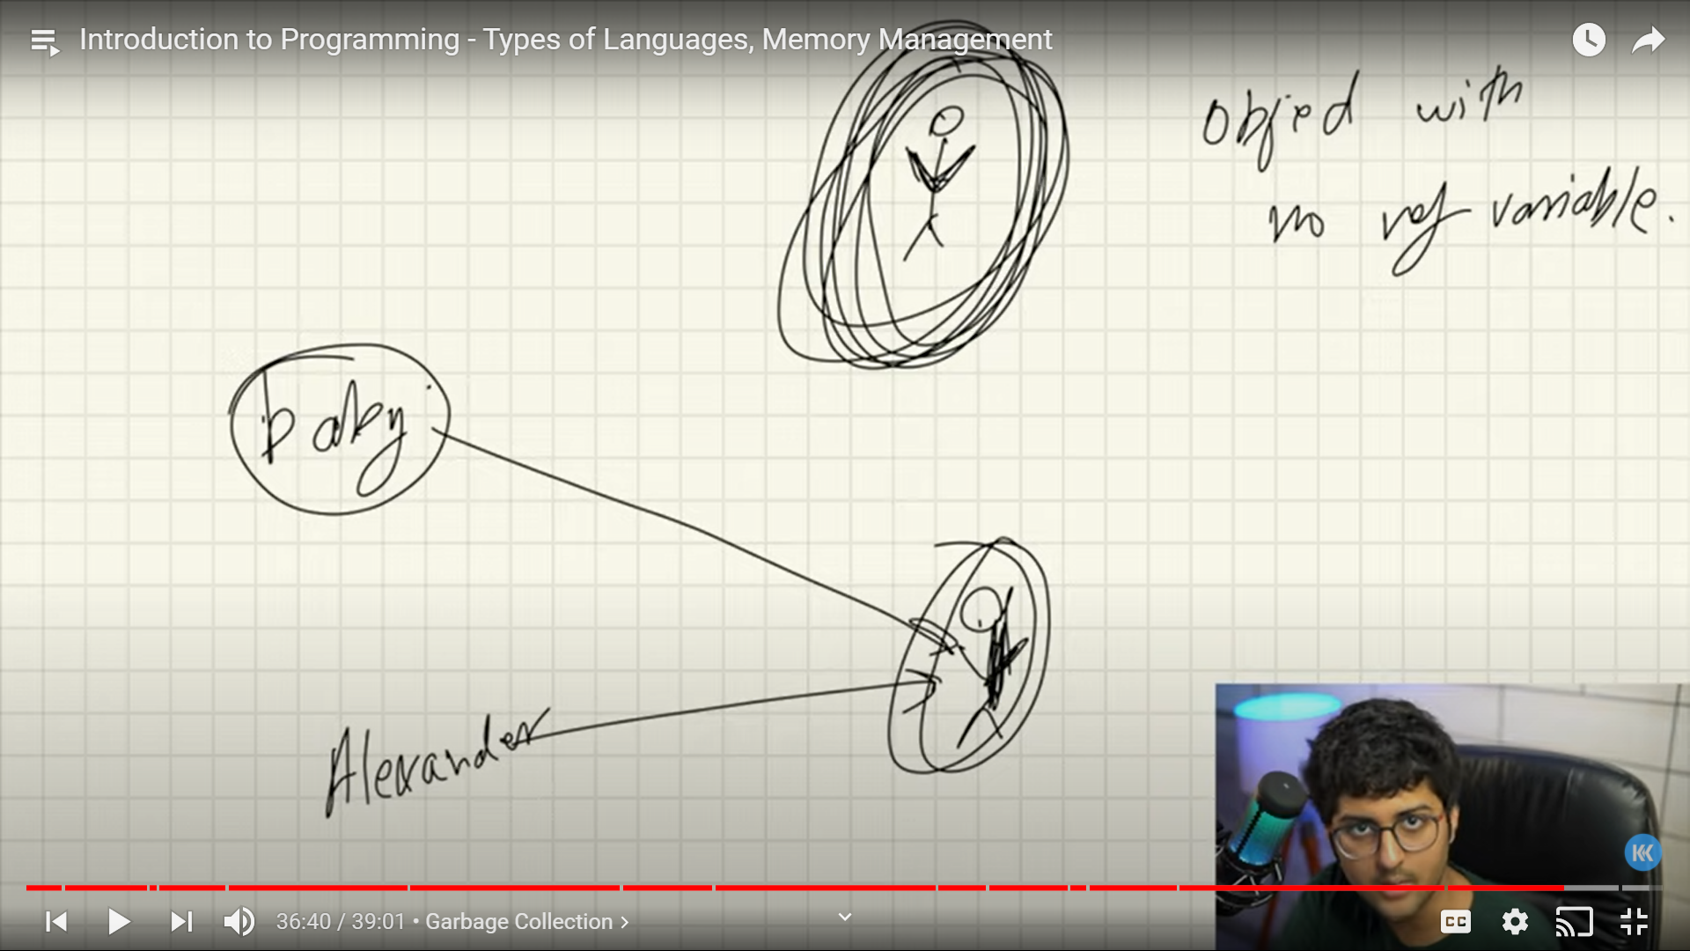  
  
  
eg : - a = 10 ; a = 20 (Garbage collector will remove object 10 form the memory since It has no reference